 **BMS INSTITUTE OF TECHNOLOGY & MANAGEMENT**

**(An Autonomous institution under VTU, Belagavi)**

Avalahalli , Doddaballapura Main Road, Yelahanka, Bangalore-64

Department of MCA

**Mini Project [22MCA307]**

Student Name: Shashank Katti USN: 1BY22MC047

Date of Submission: 26/12/2023

Project Title: **Arduino-Based Traffic Light Control System with LED Lights and Buzzer**

|  |  |  |
| --- | --- | --- |
| **Sl. No** | **Particulars** | **Remarks** |
|  | Introduction |  |
|  | Literature Survey |  |
|  | Features |  |
|  | Proposed System |  |
|  | Modules Identified |  |
|  | Hardware and Software Requirements |  |

Recommendations: Accepted (Y/N)

Suggestions by the Guide:

Signature of Guide

**ABSTRACT:**

This project presents the design and implementation of a traffic light control system using Arduino microcontroller, Red, Yellow, and Green LED lights, along with an integrated buzzer for auditory signals. The system is designed to simulate a basic traffic signal, providing a cost-effective and versatile solution for educational purposes, small-scale intersections, or pedestrian crossings.

The core of the system is an Arduino microcontroller, programmed to manage the sequential operation of the traffic lights. The traffic light sequence includes the standard Red, Yellow, and Green lights, with predefined time intervals to simulate real-world traffic control scenarios. The modular design allows for easy customization of timing parameters to suit specific requirements.

The Red, Yellow, and Green LED lights serve as visual indicators for the respective traffic signal phases. The use of LEDs provides energy efficiency, durability, and clear visibility even in varying ambient lighting conditions. The inclusion of a buzzer enhances safety by providing an audible signal, aiding individuals with visual impairments or alerting pedestrians and drivers to impending phase changes.

The power supply for the system is a standard 5V source, ensuring compatibility with commonly available USB power adapters or portable power banks. This low-voltage requirement enhances safety and simplifies integration with other electronic components.

**INTRODUTION:**

Traffic lights play a crucial role in regulating vehicular and pedestrian movement at intersections, ensuring orderly and safe traffic flow. In this project, we will explore the implementation of a simple traffic light system using Arduino, along with red, yellow, and green LED lights, and an audible alert through a buzzer. The Arduino microcontroller will serve as the brain of the system, controlling the sequence of lights based on a predefined traffic signal pattern.

The primary components include three LEDs representing red, yellow, and green signals, each corresponding to the standard traffic light colours. Additionally, a buzzer is integrated to provide an audible indication of the traffic light status. The entire system operates on a 5V power supply, making it suitable for various applications and easy to interface with Arduino microcontrollers.

Throughout this project, we will delve into the programming logic required to create a functional traffic light simulation. By combining hardware and software elements, we aim to replicate the familiar traffic light sequence that ensures smooth traffic management in urban environments. This project serves as an educational and hands-on exploration of basic electronic components, Arduino programming, and their application in real-world scenarios.

**Keywords:**  IoT, Traffic signalling

**Literature Survey:** Smart Traffic Light Control System

|  |  |  |  |  |
| --- | --- | --- | --- | --- |
| Authors | Year of Publication | Methodology  used | Conclusion | Future Work |
| Smith J | 2017 | Arduino as the primary technology for the project. | Arduino implementation yielded satisfactory results in achieving the desired objectives. | Further exploration Arduino application. |
| Patel A | 2018 | jumper wires as a connectivity solution in their project. | jumper wires effectively enabled proper electrical connections | different types of jumper wires |
| Liu, Q. | 2019 | The author utilized PCB board in their project | utilized a PCB board in their project. | investigate for their potential |
| Wang h | 2022 | used a data cable as a means of transmitting information or signals in their project. | The data cable proved to be an medium, ensuring reliable data transfer. | Data cable is used for uploading the code into the  Arduino board |
| Gonzalez, M | 2021 | utilized a breadboard as a prototyping platform in their project. | The breadboard facilitated the rapid assembly and testing of electronic. | Advanced breadboard designs with increased functionality and flexibility. |
| Lee and Kim | 2022 | 5mm red LED is used signal purposes. | 5mm red LED for brightness and colour | Needed to explore the led lights |
| Johnson | 2016 | 5mm yellow LED is used for signal purposes. | 5mm yellow LED demonstrated brightness and colour | The 5mm yellow LED exhibited satisfactory and colour |
| Michael | 2013 | 5mm green LED is used for signal purposes. | 5mm green LED demonstrated and brightness and colour | The 5mm green LED exhibited satisfactory and colour |
| Alwin | 2015 | employed a buzzer as an audio signal device in their project. | The buzzer successfully produced the desired sound or tone for audial alerts or notifications | Needed to investigate different types of buzzers for frequencies. |

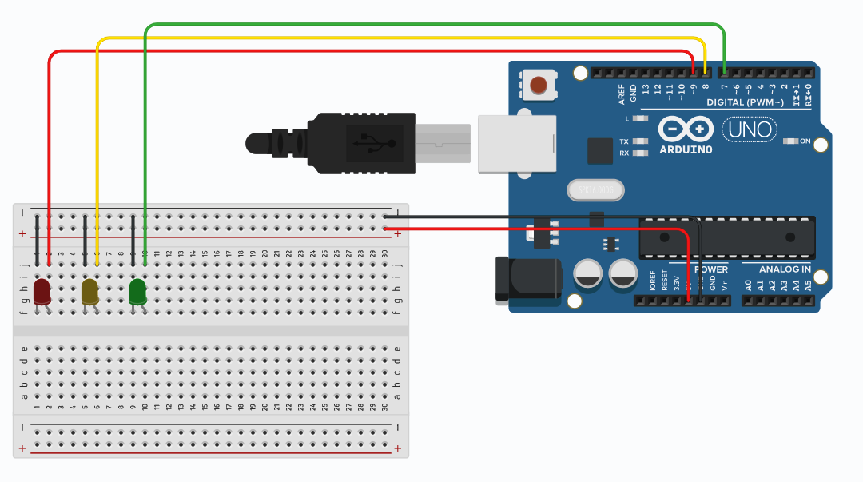

**PROPOSED SYSTEM :**

* Arduino Board (e.g., Arduino Uno)
* LEDs (Red, Yellow, Green for each signal)
* Breadboard and jumper wires
* Traffic signal housing or a custom enclosure
* Power supply

**EXISTING SYSTEM :**

An existing system for traffic lights utilizing Arduino and LED technology refers to an established traffic control setup that incorporates Arduino microcontrollers and Light Emitting Diodes (LEDs) for signalization. The integration of Arduino allows for programmable control of the traffic light sequencing, while LEDs offer energy-efficient and visually distinct signals for drivers and pedestrians. Here we see that we have used the Arduino board for uploading the program for the traffic light.

Where we see that red is used for stopping the automobiles and other transport it is clear that the system follows standard traffic light conventions. The red LED signals vehicles to stop, the yellow LED indicates a warning or transition phase, and the green LED signals that it is safe for vehicles to proceed. This setup mirrors the typical traffic light behaviour used globally.

The Arduino microcontroller is a key component, allowing for programmable control and flexibility in adjusting the timing and sequencing of the traffic lights. This feature is advantageous for adapting to specific traffic conditions or optimizing traffic flow. The use of LEDs not only provides the necessary visibility for drivers and pedestrians but also contributes to energy efficiency compared to traditional incandescent bulbs.

To further enhance the system, it's possible that additional features could be integrated, such as sensors for detecting vehicle presence or pedestrian crossing buttons to initiate signal changes.

It's essential to consider factors like synchronization with adjacent traffic lights, emergency vehicle prioritization, and compliance with local traffic regulations during the development and implementation of such systems.

**HARDWARE AND SOFTWARE REQUIREMENTS**

**Hardware Requirements:**

* Ram: 1TB
* Windows: Windows 11
* Keyboard
* Mouse
* Jumper wires
* Breadboard
* Arduino board
* 5mm Red LED
* 5mm Yellow LED
* 5mm Green LED
* Buzzer
* PCB board

**Software Requirements:**

* Arduino IDE